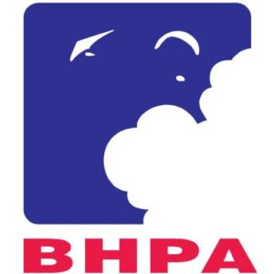 | BHPA OPEN PARAGLIDING ACCURACY NATIONAL CHAMPIONSHIPS  23-25th 2026  North Wales | 

ENTRY FORM FOR NOVICE COMPETITION
The Novice Competition is open to UK pilots without a rating or UK pilots with a CP rating who meet the following conditions:
- Have held the CP rating for no more than 24 months.
- Are entering the novice competition for the first time since achieving CP status.
- Have not previously won the novice competition.

Name

Email Address
Mobile number
Licence Number
Pilot Rating
School / Club
Glider Manufacturer
Glider Model
Glider Weight range
Glider Certification
Harness Manufacturer
Harness Certification
Helmet Manufacturer
Helmet Certification
Next of kin name

Next of kin telephone
NHS Number

Please complete and return this form to awebster168@btinternet.com no later than 10th May 2026 together with the entry fee of £85 per person (£42.50 for students*). Entries after this date will be £105 (£52.50 for students*). Cheques made payable to ‘BHPA Accuracy’, electronic transfers to 20-41-41 / 10345385. Entries will be accepted up to 08.00 on 23rd May 2026.

*Students must be under 23 years old and be in full time education as of 23rd May 2026.

Important information:

- Competitors are required to provide proof of their pilot ratings at registration.
- Competitors will be required to complete a Release of Liability / Waiver of Legal Rights and Certified Glider Affidavit forms at registration.

